**Week 9**

JSP program to display todays date

Screenshot:-

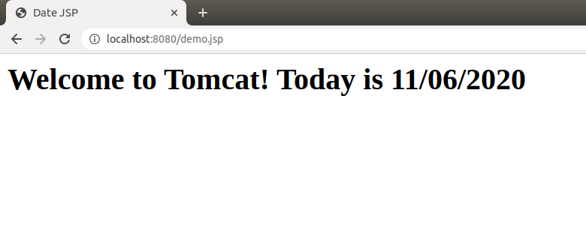

Code:-

|  |
| --- |
| <%@ page language="java" contentType="text/html"%> |
|  | <%@ page import="java.text.*,java.util.*" %> |
|  | <html> |
|  | <head> |
|  | <title>Date JSP</title> |
|  | </head> |
|  | <% SimpleDateFormat sdf=new SimpleDateFormat("MM/dd/yyyy"); %> |
|  | <body> |
|  | <h1>Welcome to Tomcat! Today is <%= sdf.format(new Date()) %></h1> |
|  | </body> |
|  | </html> |